If you need to live at RUC, you can apply for On-campus accommodation during your online application. Due to the limited providing of the rooms, students may not book a room with a success during the application and in this case, you can choose to be in the waiting list and you can get a room if other students who have booked a room choose to quit. If there is no room left in the end, you will have to book a hotel outside RUC campus.
2024 RUC International Summer School will last from July 1 to July 19 and the earliest date to check in is June 30 and the date to check out of the room is one or two nights after you have finished the courses. The accommodation fee should be paid to the reception desk after their arrival.

Charges
Type of Room | Facilities | Location | Price
Double Dormitory Room (International Students Dormitory NO.2) | Wi-Fi, two beds, public bathroom and washroom, shared washing machine, A/C | campus | 50RMB/Day/Person
Double Dormitory Room(International Students Dormitory NO.3) | Wi-Fi,two beds, independent bathroom and washroom, A/C | campus | 100RMB/Day/Room
Single Dormitory Room(International Culture Exchange Centre) | Wi-Fi,one bed, independent bathroom and washroom, A/C | campus | 120RMB/Day/Room
--International Students Dormitory NO.1--
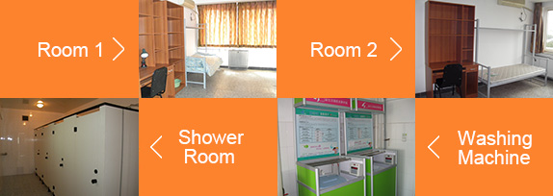

--International Students Dormitory NO.2--
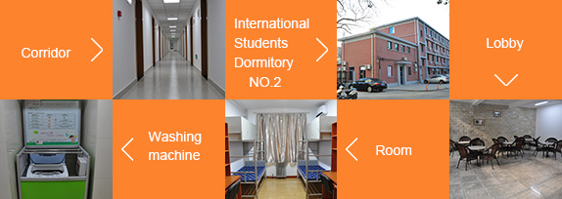

--International Students Dormitory NO.3--
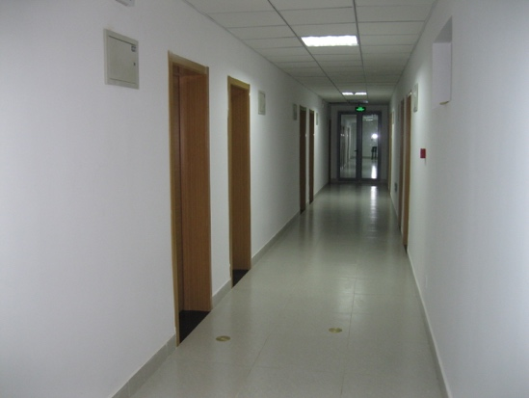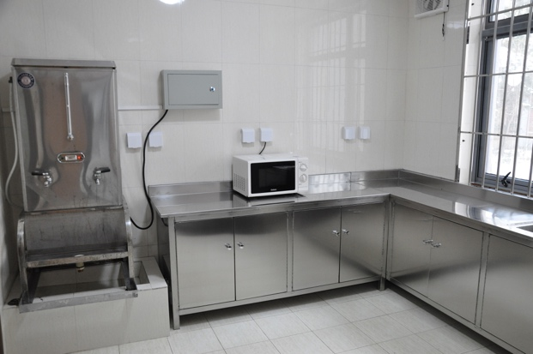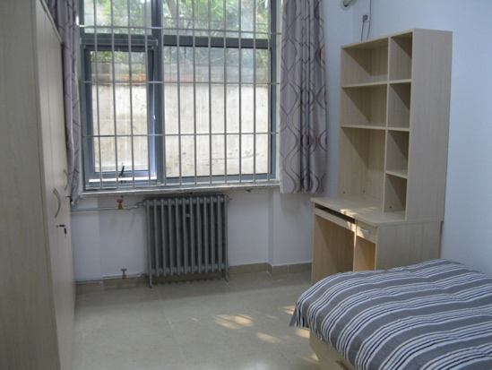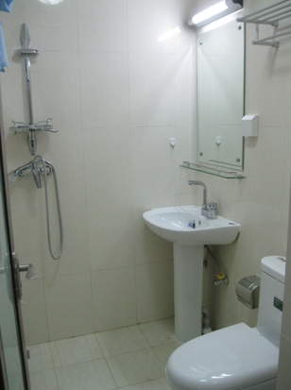
Corridor Public Kitchen Bedroom Bathroom

--International Culture Exchange Center--

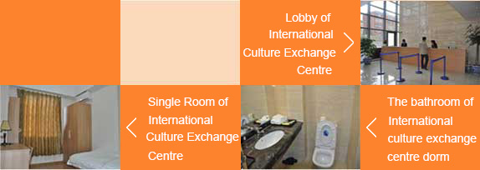
国际小学期留学生公寓住宿协议
欢迎入住中国人民大学留学生公寓！为创建和谐居住环境，请您遵守以下规定，谢谢理解与配合。预祝您人大之行顺利愉快！
一、住宿须知：
1、公寓出入时间为6:00-24:00。零点以后进楼需在门岗处登记。
2、楼内会客时间为8:00-22:00。外来访客需在门岗处登记，并于22:00前离开；21:30以后不再接待访客进楼。
3、请勿将卫生巾、卫生纸等垃圾丢于马桶内，以免造成管道堵塞。
4、外出时请切断房间内所有电源。长期外出前务必告知前台，返回公寓时应到前台重新登记。
5、房间内设备如发生故障，请及时报前台联系维修。损坏物品须照价赔偿。
6、根据中国出入境管理法有关规定，外籍人员入境，必须在办理住宿后24小时内上传签证信息，学生签证在有效期内方可在公寓内住宿。未经允许、私自留宿外籍人员是违法行为。来访客人请办理会客手续并在规定时间之前离开，不得留宿。学生签证过期者、私自留宿他人的，均将取消住宿资格。
二、禁止事项：
7、公寓内应保持安静，禁止喧哗、吵闹、大声播放音乐，以免影响他人休息。
8、房间内禁止使用大功率电器。公共楼道禁止摆放个人物品。
9、楼内禁止吸烟、乱扔烟头、随地吐痰。
10、住宿期间不得从事违反中国法律和学校规定的活动。
11、严禁酗酒、斗殴。
12、严禁留宿他人，不得自行调换房间，违反者将按自动退房处理。
如首次违反第7—9条，将予以楼内通报批评；如违反第10—12条或累计通报两次，将取消住宿资格，并通报所属学校。
房号room number： （本协议一式两份）
Housing Agreement of International Students Building
Welcome to the International Students Building of Renmin University of China . In order to create a harmonious living environment , please obey the following rules . Thank you for your understanding and cooperation . We hope you have a pleasant stay at Renmin University of China .
Ⅰ. YOU SHOULD KNOW:
1.The front doors of the building are open from 6:00—24:00 . If you return after 24:00 , you need to register at the security desk .
2.Visiting hours are from 8:00—22:00 . After 21:30 , visitors are not allowed to enter the building; in addition , visitors should register at the security desk when they come in , and they should leave before 22:00 .
3.Please don’t throw sanitary napkins , toilet paper or any other garbage into the toilet , so as not to clog the pipes .
4.Please turn off all electric appliances when going out . If you plan to leave for an extended time , you should tell the front desk , and check in again when you come back .
5.If any appliances in your room fail to work or any furniture is broken , please report it to the front desk as soon as possible . You will be responsible to pay for any damage you cause .
6.According to the Law of the People's Republic of China on the Control of the Exit and Entry of Citizens, foreigners must upload the accommodation information within 24 hours after entrance. Only with the visa in period of validity, foreign students can live in the dormitory. Without permission, it is illegal to let other foreigners stay out. Visitors must register at the Safety Department, show credentials and leave within the stipulated time. If student’s visa is expired or let other people stay overnight, the accommodating qualification will be cancelled.
Ⅱ. YOU CANNOT DO:
7.Do not make excessive noise , or play your music loudly in your apartment , because it will disturb other students .
8.Do not use high-power appliances in your room ,and do not put personal belongings in the hallway .
9.Do not smoke , or randomly throw cigarettes or other garbage down in the building .
10.Do not violate Chinese laws and university regulations during your stay .
11.Do not drink too much alcohol or fight in the building .
12.Do not let other people stay overnight in your room , and you cannot exchange rooms without permission . Any violations will terminate your right to live in this building .
Attention：
A first violation of rules 7-9, will bring an official reprimand . A violation of rules 10-12 , or repeated offenses of rules 7-9 , will terminate your right to live in this building and your school will be notified.
学生确认签字 日期
Signature: Date:
（This agreement is done in duplicate）

